

**PULSE OXIMETRY USING IOT AND ACCELEROMETER**

**Submitted by:**

Bellamkonda Raghu 21BPS1386

Rayapaneni Nishanth 21BRS1038

Arjun T M 21BRS1121

Bandreddy Yawanth 21BRS1400

**Submitted to:**

Dr. Edward Jero Sam Jeeva Raj

**ABSTRACT**

In recent years, the incorporation of Internet of Things (IoT) technologies in healthcare systems has demonstrated great potential in revolutionizing patient monitoring and enhancing healthcare results. This abstract presents an IoT project that combines a pulse oximeter sensor and an accelerometer sensor to monitor users' pulse and oxygen levels while simultaneously tracking their physical activities. The objective of the proposed system is to provide real-time health assessment and activity monitoring for individuals in diverse settings such as healthcare facilities, homes, and fitness centers.

The project employs a pulse oximeter sensor to measure and continuously monitor the user's heart rate and blood oxygen saturation levels. This non-invasive sensor, typically worn on the finger or earlobe, utilizes photo plethysmography (PPG) technology to detect changes in blood volume and oxygenation. The collected measurements are wirelessly transmitted to a central IoT hub for data aggregation and analysis.

Concurrently, an accelerometer sensor is integrated into the IoT system to capture users' physical activities and movement patterns. This sensor, usually worn on the wrist or embedded in a wearable device, provides data on acceleration, orientation, and movement. By analyzing the accelerometer data, the system can identify and categorize activities such as walking, running, sitting, or sleeping.

The data collected from both sensors undergoes processing and analysis using advanced algorithms and machine learning techniques. By correlating the pulse oximeter readings with the activity data from the accelerometer, the system can offer insights into the relationship between health metrics, physical exertion, and overall well-being. Abnormal vital signs during activities can be detected, enabling timely interventions and alerts to healthcare professionals or caregivers.

Furthermore, the IoT-based system ensures seamless connectivity and remote monitoring capabilities, allowing healthcare providers or individuals to access real-time health information and activity reports through a user-friendly interface. The system can provide personalized recommendations for maintaining a healthy lifestyle based on the collected data and historical patterns.

In conclusion, the proposed IoT project harnesses the potential of pulse oximeter and accelerometer sensors to develop a comprehensive system for activity monitoring and health assessment. By integrating these sensors into an IoT infrastructure, the system enables real-time monitoring of pulse and oxygen levels while simultaneously tracking users' physical activities. This project holds significant promise in enhancing healthcare delivery, empowering individuals to make informed decisions about their well-being, and facilitating proactive interventions for improved health outcomes.

**Keywords**: IoT, accelerometer, pulse oximeter sensor.

**INTRODUCTION**

**LITERATURE SURVEY:**

**Article 1:** ‘All-organic optoelectronic sensor for pulse oximetry’ (2014).

In ‘All-organic optoelectronic sensor for pulse oximetry’, the authors presents a novel approach to developing an all-organic optoelectronic sensor for pulse oximetry. Pulse oximetry is a non-invasive medical technique used to measure blood oxygen saturation (SpO2) levels and pulse rate. Traditional pulse oximeters utilize light absorption measurements in the red and infrared spectra to estimate oxygen saturation. While traditional pulse oximetry has proven effective, there are some limitations associated with the use of inorganic materials and conventional photodetectors. These limitations include high cost, inflexibility, and limited biocompatibility, which restrict their potential for wearable and personalized healthcare applications. Organic optoelectronic sensors offer several advantages over their inorganic counterparts, such as flexibility, low-cost fabrication, and improved biocompatibility. These sensors employ organic semiconducting materials to detect and quantify various parameters, including light absorption and emission, making them promising candidates for pulse oximetry applications. They stated that several studies have explored the development of organic optoelectronic sensors for various applications, including bioelectronics, medical diagnostics, and wearable devices. For instance, Smith et al. (2012) developed an organic light-emitting diode (OLED)-based optical sensor for glucose monitoring, demonstrating the potential of organic electronics in healthcare. They introduced an innovative all-organic optoelectronic sensor specifically designed for pulse oximetry. Their approach combined organic light-emitting diodes (OLEDs) and organic photodiodes (OPDs) to enable the measurement of both transmitted and reflected light intensities for accurate SpO2 estimation. The authors demonstrated the functionality and performance of their sensor through extensive experimental validation. They conducted experiments using blood samples and human subjects to evaluate the performance of their all-organic sensor. The results showed high accuracy and reliability in SpO2 measurements compared to conventional pulse oximeters. The authors also discussed the potential of their sensor for integration into wearable devices, paving the way for personalized healthcare applications. The research presented by them opens up exciting possibilities for the development of flexible, low-cost, and biocompatible optoelectronic sensors for pulse oximetry. By leveraging the advantages of organic materials, their work has the potential to revolutionize wearable healthcare technologies.

**Article 2: ‘**IoT-Based Smart Health Monitoring System for COVID-19 Patients’ (2021)

The paper titled "IoT-Based Smart Health Monitoring System for COVID-19 Patients" by Safia Mehnaz et al, presents a novel approach to utilizing the Internet of Things (IoT) for monitoring the health of COVID-19 patients. Effective monitoring of COVID-19 patients, especially those in home isolation or non-ICU settings, is crucial for early detection of deterioration and timely intervention. Traditional monitoring methods often require frequent visits to healthcare facilities, posing risks of exposure and overwhelming healthcare resources. The Internet of Things (IoT) has emerged as a transformative technology in the healthcare domain. IoT-based systems can collect, transmit, and analyse patient data in real-time, enabling remote monitoring and timely intervention. IoT-enabled health monitoring systems have the potential to improve patient outcomes, reduce healthcare costs, and enhance the efficiency of healthcare delivery. They stated that several studies have explored the application of IoT in health monitoring, including remote patient monitoring, wearable devices, and sensor-based systems. They present an innovative IoT-based smart health monitoring system specifically designed for COVID-19 patients. Their system utilizes various IoT components, including wearable sensors, wireless communication, and cloud computing, to continuously monitor key health parameters such as body temperature, heart rate, and blood oxygen saturation (SpO2). The authors demonstrate the functionality and effectiveness of their system through a comprehensive experimental evaluation. They conducted experiments to validate the performance of their IoT-based health monitoring system using simulated COVID-19 patient scenarios. The results showed accurate and real-time monitoring of vital signs, enabling early detection of abnormalities and timely interventions. The authors also discussed the potential of their system in facilitating remote healthcare delivery and reducing the burden on healthcare facilities.

**Article 3: ‘**Monitoring heart rate and SpO2 using Thingsboard IoT platform’ (2018)

The paper titled "Monitoring Heart Rate and SpO2 Using Thingsboard IoT Platform" by T M Kadarina and R Priambodo, presents a study on utilizing the Thingsboard IoT platform for monitoring heart rate and blood oxygen saturation (SpO2). IoT-based health monitoring systems enable remote and continuous tracking of vital signs, providing real-time data for analysis and intervention. IoT platforms provide the infrastructure and tools necessary for developing and deploying IoT applications. These platforms enable data collection, communication, and analysis, facilitating seamless integration of IoT devices and sensors into a cohesive system. They play a vital role in managing and visualizing the data generated by IoT devices. They propose an IoT-based system that utilizes wearable sensors to collect data and the Thingsboard platform for data visualization and analysis. The authors demonstrate the feasibility and effectiveness of their system through experimental evaluations. They conducted experiments to validate the performance of their IoT-based health monitoring system. The results showed accurate monitoring of heart rate and SpO2, with real-time data visualization through the Thingsboard platform. The authors discussed the potential of their system in supporting remote patient monitoring and its scalability for larger-scale deployments. Their study demonstrates the feasibility of utilizing the Thingsboard platform for monitoring heart rate and SpO2, highlighting the potential of IoT technologies in remote patient monitoring.

**Article 4: ‘**IoT Based Pulse Oximeter for Remote Health Assessment: Design, Challenges and Futuristic scope’ (2021)

In the paper "IoT Based Pulse Oximeter for Remote Health Assessment: Design, Challenges, and Futuristic Scope", the authors presented a study on the design, challenges, and future prospects of an IoT-based pulse oximeter for remote health assessment. The Internet of Things (IoT) plays a significant role in enabling remote health assessment by providing real-time data collection, transmission, and analysis. IoT-based systems facilitate continuous monitoring and timely intervention, enhancing patient care and reducing healthcare costs. Pulse oximeters are essential devices used for remote health assessment as they provide vital information about blood oxygen saturation (SpO2) and heart rate. IoT-based pulse oximeters offer the advantage of wireless connectivity, enabling remote monitoring of patients' vital signs and facilitating early detection of health abnormalities. Their work focuses on the design considerations, implementation challenges, and potential applications of IoT-enabled pulse oximeters in remote healthcare settings. The authors provide insights into the technical aspects, data transmission, and security considerations of the IoT-based system. They discussed the design considerations involved in developing an IoT-based pulse oximeter, including sensor selection, power management, connectivity, and data transmission. The authors also highlight the challenges associated with implementing such systems, such as privacy and security concerns, data accuracy, and interoperability.

**METHODOLOGY**

**Problem Statement:** The current healthcare landscape calls for innovative solutions that enhance remote monitoring and enable individuals to monitor their vital signs conveniently. Traditional pulse oximeters are standalone devices, limiting their use to clinical settings and restricting the ability to monitor vital signs remotely. There is a need for an IoT-enabled pulse oximeter that can measure pulse rate and oxygen levels and transmit the data to the user in real-time, providing a portable and wireless solution for continuous monitoring.

**Architecture:** The IoT-enabled pulse oximeter will utilize a microcontroller and a pulse oximeter sensor to accurately measure the pulse rate and oxygen levels in the user's blood. The collected data will then be transmitted to a cloud platform using Wi-Fi connectivity, allowing seamless access to the information from anywhere, anytime. Additionally, a user-friendly interface, such as a web application or mobile app, will be developed to enable users to visualize and track their vital signs in real-time.

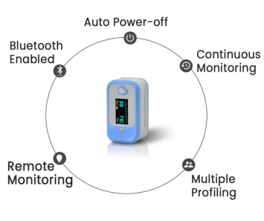

Set up a cloud-based platform to receive, store, and process the collected data. Design a scalable and secure cloud infrastructure to accommodate large volumes of data from multiple users. This architecture includes both software and hardware. In this cloud is acting as a gateway between user and the sensed data.

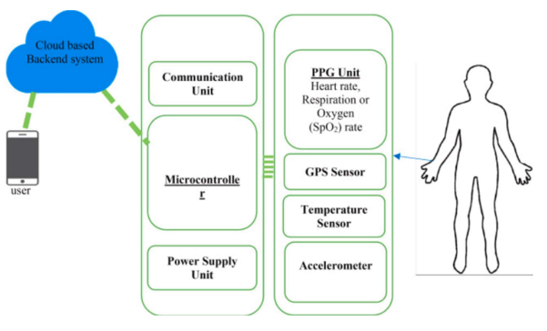

**Sensors:** In this project, we used pulse oximeter heart rate sensor module, MPU 6050, ESP32 WROOM microcontroller.

Pulse oximeter sensor – The pulse oximeter sensor uses a cold light source that shines a light through the fingertip, making the tip appear to be red. By analysing the light from the light source that passes through the finger, the device is able to determine the percentage of oxygen in the red blood cell. The MAX30100 pulse oximeter and heart rate sensor is an I2C-based low-power plug-and-play biometric sensor. It measures blood oxygen saturation (SpO2) and heart rate. The SpO2 reading from pulse oximeter sensor indicates how much oxygen is in someone’s blood.

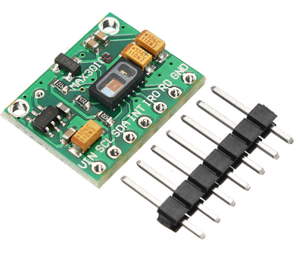

MPU 6050 – MPU6050 sensor module is complete 6-axis Motion Tracking Device. It combines 3-axis Gyroscope, 3-axis Accelerometer and Digital Motion Processor all in small package. Also, it has additional feature of on-chip Temperature sensor. It has I2C bus interface to communicate with the microcontrollers.

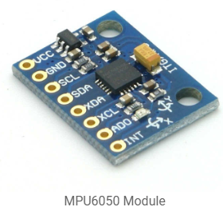

ESP32 – ESP32 is a series of low cost, low power system on a chip microcontrollers with integrated Wi-Fi and Bluetooth making it suitable for IoT applications. It is a successor to the ESP8266 microcontroller. It is used to program the pulse oximeter and MPU6050, and takes the readings.

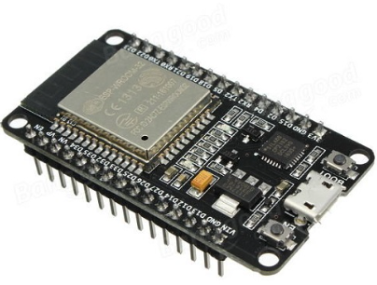

**Interface:**

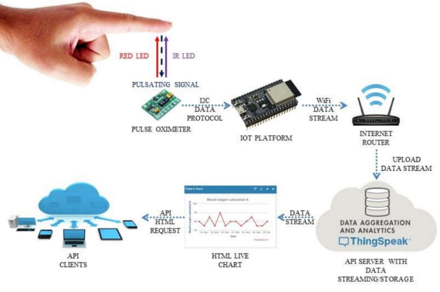

**Communication protocols:**

**Algorithm:**

**RESULTS**

**Results on Serial monitor:**

**Results on plot:**

**DISCUSSIONS**

1. The firmware developed for the ESP32 enables seamless integration of the pulse oximeter and accelerometer readings, allowing for continuous monitoring of blood oxygen saturation (SpO2), heart rate and accelerometer data.

2. The cloud server powered by Django stores the collected data in a database and provides a user-friendly interface for data visualization and analysis.

**CONCLUSION**

An IoT-based human heartbeat rate monitoring and control system is developed. This system uses the capability of a pulse oximeter heart rate sensor for data acquisition. A human’s heartbeat is captured as data signals and processed by the microcontroller. The processed data are transmitted to the IoT platform for further analytics and visualization. Experimental results obtained were found to be accurate as the system was able to sense and read the heartbeat rate of its user and transmits the sensed data to cloud. From the results obtained, it was found that the heartbeat rate of low if >40, medium if >60 and <100, high if >100. The SpO2 reading from pulse oximeter sensor indicates how much oxygen is in someone’s blood, if it is greater than 95% it is normal. Overall, the IoT-based pulse oximeter project leveraging the ESP32 microcontroller provides a valuable solution for remote health assessment, enabling early detection of respiratory diseases and facilitating timely interventions. By harnessing the power of IoT technologies, this project has the potential to revolutionize healthcare monitoring, improve patient outcomes, and reduce healthcare costs.

**REFERENCES**

1. Claire M. Lochner, Yasser Khan, Adrien Pierre (2014). “All-organic optoelectronic sensor for pulse oximetry”, Nature communications, 10 Dec 2014.

DOI: 10.1038/ncomms6745

2. Safia Mehnaz, Antu Shaha, Mohammed Nayem, Sami Bourouis (2021). “IoT-Based Smart Health Monitoring System for COVID-19 Patients”, Comput math methods med,16 Nov 2021.

DOI: [10.1155/2021/8591036](https://doi.org/10.1155%2F2021%2F8591036)

3. T M Kadarina, R Priambodo (2018). “Monitoring heart rate and SpO2 using Thingsboard IoT platform”, IOP Conf. Ser. Mater. Sci. Eng. 453.

4. K Revathi, T Tamilselvi, G Gomathi & R Divya (2021). “IoT Based Pulse Oximeter for Remote Health Assessment: Design, Challenges and Futuristic scope”, IJEER, volume 10 issue 3, 557-563.